**SWEDES IN SACRAMENTO**

** 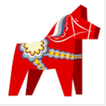

[**www.monitorlodgesacramento.org**](http://www.monitorlodgesacramento.org)